CSE 2320 Notes 10: Stacks and Queues

(Last updated 11/8/26 12:47 AM)

CLRS 10.1

10.A. Stacks

Abstraction (Last-In, First-Out) and Operations

Push Pop Top Empty

Policies Correspond to Code (Θ(1) for all operations)

1. Direction of growth in array

2. What does stack pointer indicate?

a. Next available element:

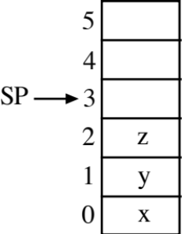

Empty: return sp==0;

Push(x): A[sp++]=x;

Pop: return A[--sp];

Top: return A[sp-1];

b. Most recently pushed element:

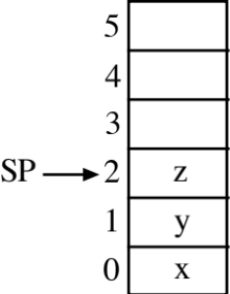

Empty: return sp==(-1);

Push(x): A[++sp]=x;

Pop: return A[sp--];

Top: return A[sp];

Also easy to implement using a linked list (CLRS exercise 10.2-2):

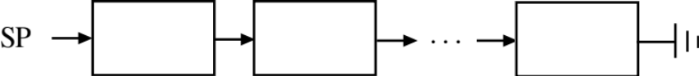

Applications

1. Run-time environment for programming languages.
2. Compilers/parsing
3. Depth-first search on graphs (Notes 14).

10.B. Rat-in-a-Maze Using a Stack (Depth-First Search)

. . . . . . . . . . . . . . . . .
. # . # # # # # ^ ^ ^ ^ ^ ^ ^ ^ .
. # . # . . . # . ^ . . . . . . .
. # # # . # # # . ^ ^ ^ . ^ ^ ^ .
. . . . . # . . . ^ . ^ . ^ . ^ .
. . # # # . ^ . ^ ^ ^ . ^ .
. . . . . # . . . . . . . . .
. . # # # . ^ ^ ^ ^ ^ ^ ^ .
. . . . . # . . . ^ . . . . . ^ .
. ^ . # # # . ^ ^ ^ . ^ . ^ ^ ^ .
. ^ . # . ^ . ^ . . . ^ . ^ . . .
. # # # . ^ ^ ^ ^ ^ . ^ ^ ^ . .
. # . . . . . . . . . . . . . .
. # # # # # # # # # . .
. . . . . . . # . . . . . .
. . . # # # # # # # .
. . . . . . . . . . . . . . . . .

Array initially contains 0/1 for each position.
0=open (“ ”), 1=wall (“.”).

Stack contains positions on current path.

Array entries change to reflect search status: 2=discovered (“^”), 3=solution (“#”).

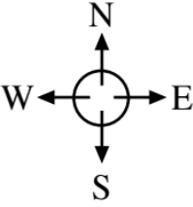

http://ranger.uta.edu/~weems/NOTES2320/VERMIN/ratDFSrec.c
. . .
int DFS(int row,int col)
{
if (maze[row][col]!=0)
return 0; // report failure
if (row==stopRow && col==stopCol)
{
maze[row][col]=3;
return 1; // report success
}
maze[row][col]=2; // Mark slot as discovered
if (!DFS(row-1,col)) // Try North
if (!DFS(row,col+1)) // Try East
if (!DFS(row+1,col)) // Try South
if (!DFS(row,col-1)) // Try West
return 0;
maze[row][col]=3; // On final path
return 1; // Propagate success through recursion
}

int main()
{
readInput();
printf("Initial maze:\n");
printMaze();
if (DFS(startRow,startCol))
printf("Success:\n");
else
printf("Failure:\n");
printMaze();
}

http://ranger.uta.edu/~weems/NOTES2320/VERMIN/ratDFSstack.c
. . .
typedef enum {init,north,east,south,west} direction;
typedef struct {
int row,col;
direction current;
} stackEntry;
. . .

int DFS(int row,int col)
{
stackEntry work;
int returnValue;
work.row=row;
work.col=col;
work.current=init;
pushStack(work);
while (!emptyStack())
{
work=popStack();
if (work.current==init) // Just arrived here?
{
if (maze[work.row][work.col]!=0) // Not an open slot?
{
returnValue=0;
continue;
}
if (work.row==stopRow && work.col==stopCol) // At destination?
{
maze[work.row][work.col]=3;
returnValue=1;
continue;
}
maze[work.row][work.col]=2; // Mark slot as discovered
}
else if (returnValue==1) // Backtracking from successful search?
{
maze[work.row][work.col]=3;
continue;
}
else if (work.current==west) // No other directions to try
{
returnValue=0;
continue;
}
// Try next direction. Push current position and new position
work.current++;
pushStack(work);
switch (work.current) {
case north: work.row--; break;
case east: work.col++; break;
case south: work.row++; break;
case west: work.col--; break;
}
work.current=init;
pushStack(work);
}
return returnValue;
}
10.C. Evaluating Postfix Expressions Using a Stack

Infix: ( 1 + 2 ) * ( 3 + 1 ) / ( 1 + 1 + 1 )

Postfix: 1 2 + 3 1 + * 1 1 + 1 + /

Prefix: / * + 1 2 + 3 1 + + 1 1 1

Evaluating Postfix – Store operands on stack until popped for operator

while (unprocessed input tokens)
{
get token;
if (token is an operand)
stack.push(token);
else // token is an operator
{
operand2=stack.pop();
operand1=stack.pop();
stack.push(result of (operand1 token operand2));
}
}
result=stack.pop();
if (!stack.empty())
<error>

Stack__________
1: 1
2: 1 2
+: 3
3: 3 3
1: 3 3 1
+: 3 4
*: 12
1: 12 1
1: 12 1 1
+: 12 2
1: 12 2 1
+: 12 3
/: 4

10.D. Queues

Abstraction (First-In, First-Out) and Operations

Enqueue (at tail) Dequeue (from head) Empty

Applications

1. Huffman coding using two queues
( http://ranger.uta.edu/~weems/NOTES2320/huffman2Q.c )

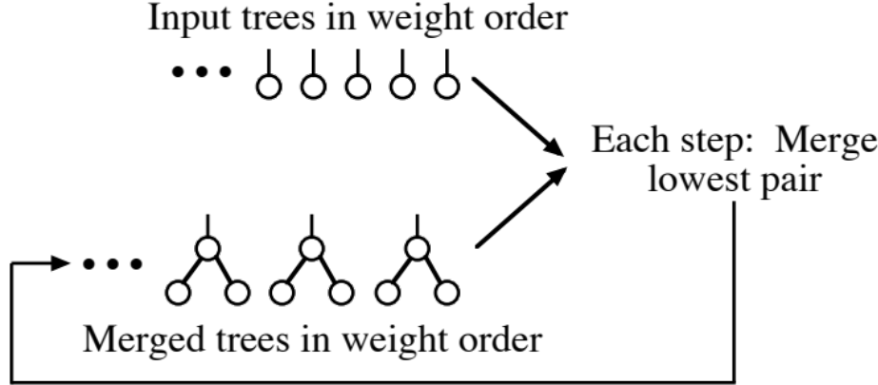

2. Data communications

3. Message-based concurrent programming

4. Event-interrupt handlers

5. Breadth-first search

a. Graphs (Notes 14)

b. Rat in a maze ( http://ranger.uta.edu/~weems/NOTES2320/VERMIN/ratBFSqueue.c )

. . . . . . . . . . . . . . . . .
. # . # # # # # ^ ^ ^ ^ ^ ^ ^ ^ .
. # . # . . . # . ^ . . . . . . .
. # # # . # # # . ^ ^ ^ . ^ ^ ^ .
. . . . . # . . . ^ . ^ . ^ . ^ .
. ^ . ^ ^ # # # . ^ . ^ ^ ^ . ^ .
. ^ . ^ . . . # . . . . . . . . .
. ^ ^ ^ . # # # . ^ ^ ^ ^ ^ ^ ^ .
. . . . . # . . . ^ . . . . . ^ .
. ^ . # # # . ^ ^ ^ . . ^ ^ ^ .
. ^ . # . ^ . ^ . . . . ^ . . .
. # # # . ^ ^ ^ ^ ^ . ^ ^ ^ . .
. # . . . . . . . . . . . . . .
. # # # # # # # # # . .
. . . . . ^ . ^ . # . . . . . .
. ^ ^ ^ ^ ^ . ^ . # # # # # # # .
. . . . . . . . . . . . . . . . .

Demo of both versions of search:

http://ranger.uta.edu/~weems/NOTES2320/VERMIN/rat.drag.html
Implementation using A[0] . . . A[n-1] (aside starting with Spring 2020)

Non-Reusable Circular

Initialize tail=head=0; tail=head=0;

Empty return tail==head; return tail==head;

Enqueue(x) A[tail++]=x; A[tail++]=x;
if (tail==n) if (tail==n)
< error > tail=0;
if (tail==head)
< confused >

Dequeue if (tail==head) if (tail==head)
< empty > < empty >
return A[head++]; temp=A[head++];
if (head==n)
head=0;
return temp;

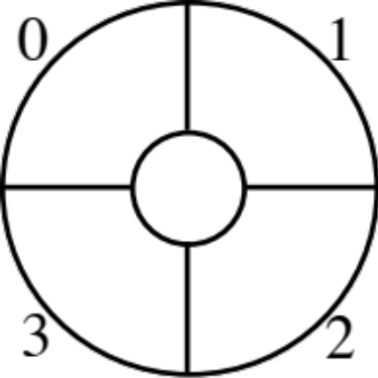

Implementation using a linked list (CLRS exercise 10.2-3):

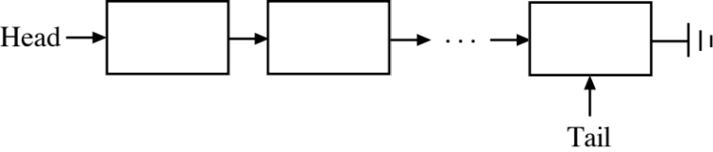

Aside: Suppose a queue has pointers to outgoing messages. How would you maintain:

1. The average length of an outgoing message?

2. The maximum length of an outgoing message?

What if messages are in a stack instead?

Solution for queue is to use two stacks (CLRS exercise 10.1-6):

Initialize:

Initialize inStack
Initialize outStack

Enqueue(message, length):

if inStack.empty or length > inMaximum
inMaximum=length
inStack.push(message, length)

Dequeue:

if outStack.empty
if inStack.empty
<ERROR>
(message, length)=inStack.pop
outStack.push(message, length)
while !inStack.empty
(message, length)=inStack.pop
outStack.push(message, max(outStack.top.length, length))

(message, length)=outStack.pop
return message

MaxLength:

if inStack.empty and outStack.empty
<ERROR>
if outStack.empty
return inMaximum
if inStack.empty
return outStack.top.length
return max(inMaximum, outStack.top.length)

Amortized vs. actual cost of operations

